**Setting Up an NTRIP Client Relay Station**

**Version 1.0**

**Kenny Trussell**

**July 28, 2021**

1. Hardware:

*Overview: A Raspberry Pi 4 is used as an NTRIP client to pull RTCM3 correction data from rtk2go.com. An Adafruit Feather M0 LoRa module is used to transmit the corrections to an identical module that is connected to the GPS.*

An Adafruit Feather M0 LoRa module is mounted to a proto hat for a Raspberry Pi. Prepare the Feather by soldering its headers on and installing a u.FL female SMT connector.

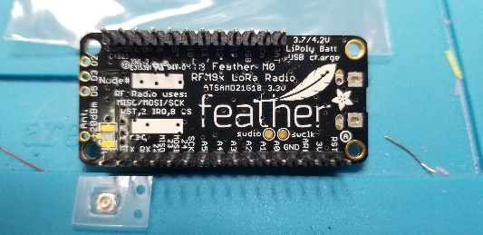 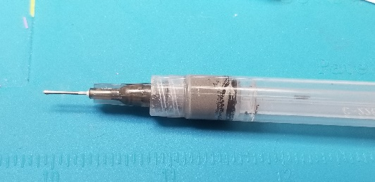 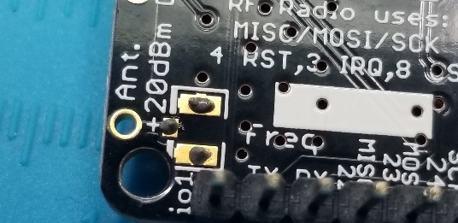 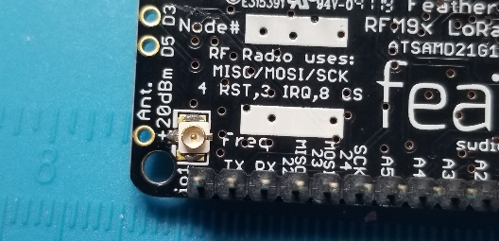 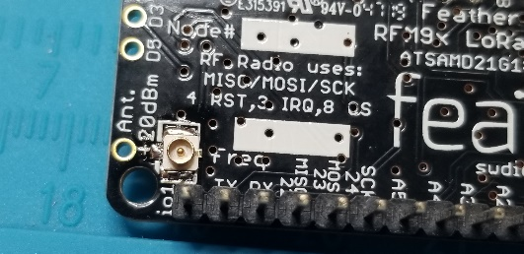

On the proto hat, the only connections are +5V, ground and serial out from the Raspberry Pi to the Feather on Pin 11. The antenna pigtail has a u.FL connector plugged onto the feather. A 4” cable tie keeps the cable from coming loose.

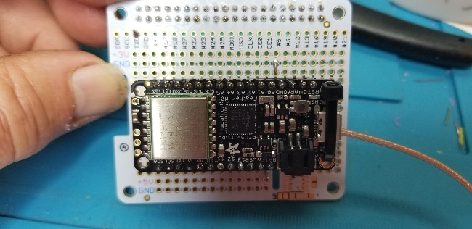 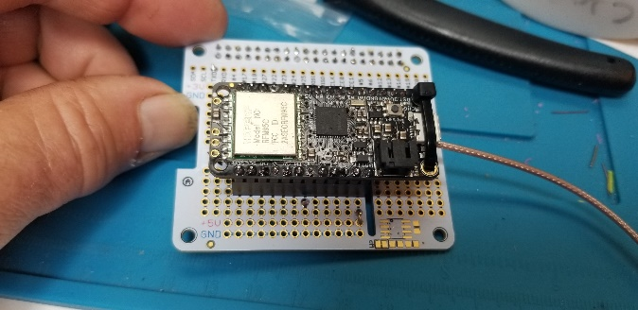 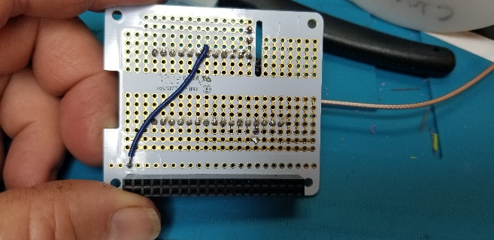 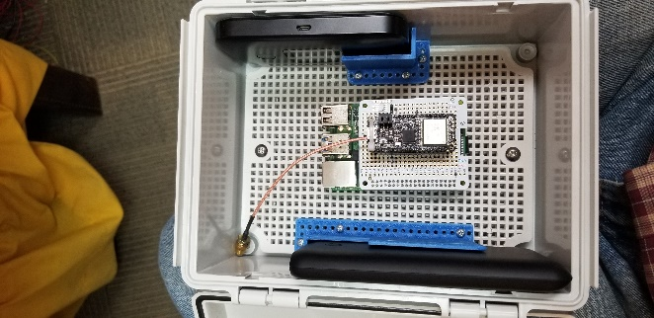

1. Installing the Adafruit Feather M0 LoRa Firmware

Using the Arduino IDE, load the latest version of the Serial to LoRa Transmit program. At this time it is named “Serial_to_LoRa_TX_V4-4.ino”.

1. Setting Up the Raspberry Pi:
2. Image the SD Card with the latest Raspian image.
3. Create wpa_supplicant.conf in the boot (root) directory of the SD card. All possible Wi-Fi hotspots that the device might connect to should be defined in this file.
4. Create an empty file named SSH in the boot (root) directory of the SD card.
5. Insert card in Raspberry Pi and boot it up.
6. Use an IP scanner such as Angry-IP Scanner to find the raspberry pi on the network.
7. SSH into the Pi using Putty or some other terminal program.
8. Change password on the Pi to a password of your choice using the passwd command.
9. Be sure all is up to date with “sudo apt-get update” and “sudo apt-get upgrade”.
10. Download RTKLIB from github and compile with GCC with these commands:

git clone <https://github.com/tomojitakasu/RTKLIB.git>

cd /home/pi/RTKLIB/app/str2str/gcc

make

1. The serial port name is different on different versions of the Raspberry Pi. On the Pi 4, it is ttyS0. If you run the command “dmesg | grep tty”, you will notice that the console is assigned to ttyS0 as follows: 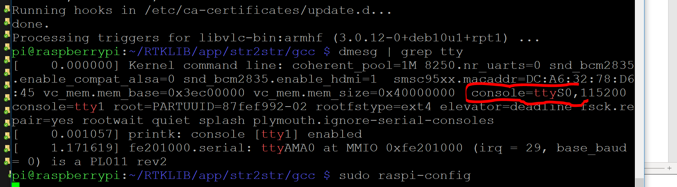
2. We have to go into raspi-config and change the serial port from being used by Linux to being just a serial port. The first 8 steps of <https://pimylifeup.com/raspberry-pi-serial/> generally explain how. Note that https://www.instructables.com/id/Read-and-write-from-serial-port-with-Raspberry-Pi/ is useful also. Here are the exact steps:
   1. Run “sudo raspi-config”.
   2. Go to “Interface options” – “Serial Port”. Select No to “Would you like a login shell to be accessible over serial?” Answer “yes” to “Would you like the serial port hardware to be enabled?” You should see a confirmation of the changes. Then exit raspi-config.
   3. Reboot in raspi-config (you will be asked if you want to as you exit) or with “sudo reboot”.
3. Now when you run the “dmesg | grep tty” command, you will see that ttyS0 is shown as serial: 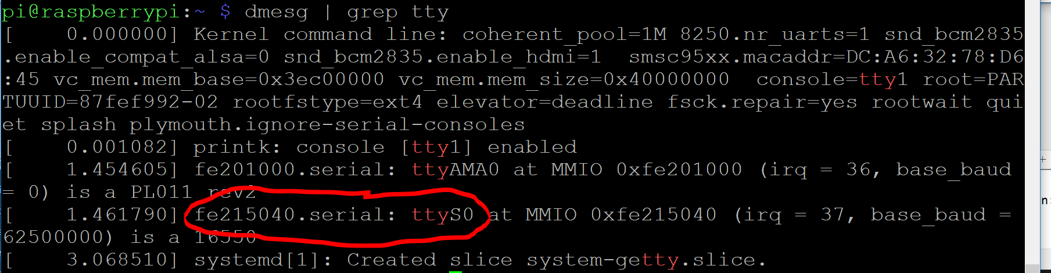
4. After that, you can make RTKLIB output the data with (note this is all one command on one line):

sudo /home/pi/RTKLIB/app/str2str/gcc/str2str -in ntrip://un:pw@rtk2go.com:2101/BASENAME -out serial://ttyS0:115200:8:n:1

where BASENAME is the name of the fixed base that is providing correction data to rtk2go.com.

(note un:pw can be anything as there is really no username and password required)

1. You will see RTKLIB reading data from rtk2go.com:

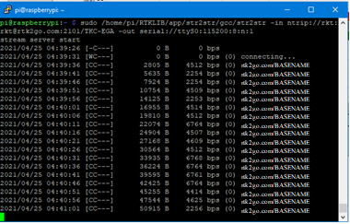

1. If you have a serial to USB converter connected to GND and the serial TX line on the Pi, you will see binary data in PuTTY or another terminal program.
2. Hit Ctrl-C to stop the command and return to the command prompt.
3. Now write the following command to the Raspberry Pi’s /etc/rc.local file above the “exit 0” statement so that the Raspberry Pi will run ntrip client automatically when starting (using “sudo nano /etc/rc.local” or your favorite editor) (once again this is all one line):

nohup sudo /home/pi/RTKLIB/app/str2str/gcc/str2str -in ntrip://un:pw@rtk2go.com:2101/BASENAME -out serial://ttyS0:115200:8:n:1 > /dev/null &

1. Reboot (“sudo reboot”) and you are done!